



Reginald Mitchell Primary School
Pupil Premium Strategy
2025-2028

Pupil premium strategy statement

Before completing this template, you should read the guidance on using pupil premium.

Before publishing your completed statement, you should delete the instructions (text in italics) in this template, including this text box.

This statement details our school’s use of pupil premium (and recovery premium for the 2025 to 2026 academic year) funding to help improve the attainment of our disadvantaged pupils.

It outlines our pupil premium strategy, how we intend to spend the funding in this academic year and the effect that last year’s spending of pupil premium had within our school.

School overview
Detail | Data
School name | The Reginald Mitchell Primary School
Number of pupils in school | 206
Proportion (%) of pupil premium eligible pupils | 65 pupils = 32%  6 x EYPP  57 x PP
Academic year/years that our current pupil premium strategy plan covers (3 year plans are recommended) | 2025-2028
Date this statement was published | Sept 2025
Date on which it will be reviewed | July 2026
Statement authorised by | Local Advisory Board
Pupil premium lead | L Jukes
Governor / Trustee lead | Mrs S Blood

Funding overview
Detail | Amount
Pupil premium funding allocation this academic year | £80, 295
Recovery premium funding allocation this academic year | £0
Pupil premium funding carried forward from previous years (enter £0 if not applicable) | £0
Service Premium (£340 per pupil) | £680
Total budget for this academic year  If your school is an academy in a trust that pools this funding, state the amount available to your school this academic year | £80,995

Part A: Pupil premium strategy plan

Statement of intent
ETHOS STATEMENT
Reginald Mitchell Primary School offers a positive, inclusive, safe learning environment for its learners, in which everyone has equal and individual recognition and respect. We celebrate difference and are committed to the continuous improvement and fulfilment of potential in every child. We encourage increasing independence and confidence amongst the children. Everyone within the school has an important role to play in sharing responsibility for the development of positive attitudes to learning and excellent behaviour.

AIMS
We have high aspirations and ambitions for our children and we believe that every child can achieve. By undertaking the approach of’ profile, predict and prevent’ in our Triple A Strategy, Reginald Mitchell Primary aims to achieve the following for all DA pupils.

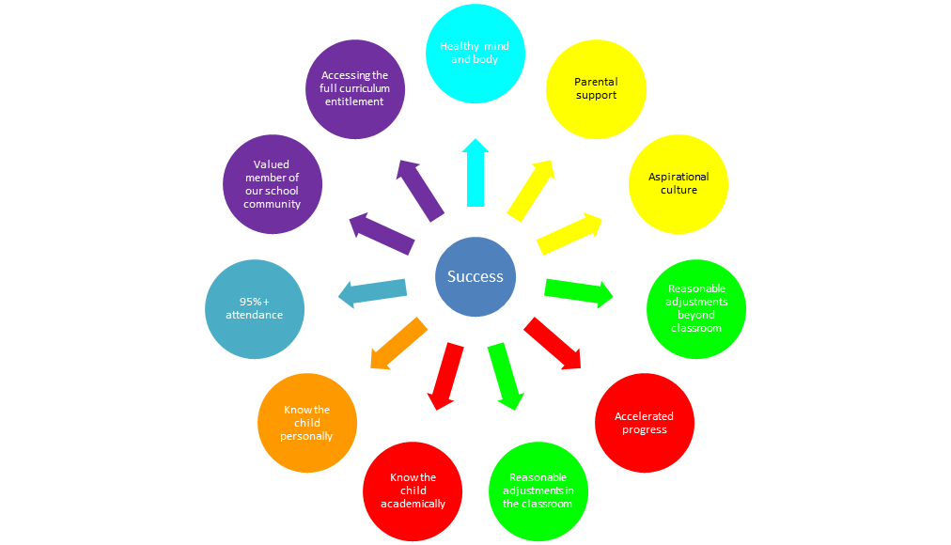
By doing so we believe we will have an impact on pupils:
- self-esteem and confidence
- progress and achievement
- attitude towards learning and attendance
- well-being and mental health
- access to their full curriculum entitlement

KEY PRINCIPLES TO ACHIEVE SUCCESS:

Quality First Teaching
Our Leaders believe this is the key to the success of the vast majority of our pupils.
- The high expectations of our staff, strong knowledge of educational pedagogy and the national curriculum content ensure lessons will move swiftly using AfL precisely to
respond to needs.
- Our classrooms promote an honest, open and independent approach to learning where misconceptions are used wisely to embed and deepen learning.
- Pace is ambitious, weaving in time to practice, embed and deepen knowledge.
- Reasonable adjustments are made to ensure all learners meet at least age related
expectation and intervention is both swift, purposeful and specific to ensure those who are working below expected levels can achieve.
- Formative and summative assessment is used effectively to identify the gains pupils have made and our staff respond appropriately.
- The deployment of resources such as staff is flexible and reflective to need.
Aspirational Mindset
- We will promote a no excuses culture across all our schools where barriers are quickly challenged and the collaborative working of the MAT is used to tackle them with rigour and speed.
- Target setting will avoid all stereotyping and will ensure that opportunities are
provided for our most disadvantaged to achieve their full potential.
Attendance and Behaviour
- Our schools provide clear behaviour and attendance policies which are applied with consistency by all.
- Strong CPD support leaders to monitor, tackle and rectify any issues relating to
behaviour, SEMH and poor attendance.
- Intervention will be rapid, personalised and supportive, also extending into the home if appropriate.
Cultural Capital
- Our schools recognise the need to enhance the breadth and range of ‘life’ experiences for many of our most disadvantaged.
We will do this by ensuring all attend clubs, have access to all trips, are encouraged to learn how to play a musical instrument, are provided with access to high quality and wide range of reading materials and have time to learn and use a wide range of subject specific and creative vocabulary.

Challenges

This details the key challenges to achievement that we have identified among our disadvantaged pupils.
Challenge number | Detail of challenge
1 | A small number of disadvantaged pupils are persistently absent. The main barriers to regular attendance include financial pressures leading to extended family holidays during term time and the additional challenges associated with some pupils' special educational needs and disabilities (SEND), which can impact their ability to attend school consistently.
2 | Not all disadvantaged pupils achieve a Good Level of Development (GLD) by the end of the EYFS. Contributing factors include PSED, language and communication delays. Pupils who join Reception without attending our school nursery often have lower starting points.
3 | A significant proportion of the pupils in KS1 and KS2 working below age-related expectations in writing, reading and mathematics are disadvantaged. The gaps in their knowledge, skills and understanding are due to varying factors, some include: life experiences, lack of consistent and sequential quality first teaching, fewer positive role models and lower levels of parental support.
4 | A significant proportion of our disadvantaged pupils have a SEND in the areas of cognition and learning, communication and interaction difficulties or SEMH difficulties. Pupils may face a range of barriers to learning, including difficulties linked to their cognition and learning needs, lower levels of parental engagement or understanding of their child’s needs, delays in accessing appropriate external agency support, and challenges with concentration, resilience and self-regulation.
5 | Engagement in the wider curriculum and enrichment offer is impacted by a lack of parental engagement, aspiration and affordability. For reasons such as lack of finances to support the wider curriculum, lack of role models.
6 | A proportion of our disadvantaged pupils have experienced a range of challenges, including instability, trauma, or disrupted attachments, which can impact their emotional wellbeing, behaviour, engagement with learning, and academic progress.

Intended outcomes
This explains the outcomes we are aiming for by the end of our current strategy plan, and how we will measure whether they have been achieved.
Intended outcome | Success criteria
1. To sustain attendance for our disadvantaged pupils, particularly our disadvantaged SEND pupils. | The PA gap between disadvantaged and non-disadvantaged pupils will be maintained below national and close further for those disadvantaged pupils that also have a SEND.
2. Disadvantaged pupils joining Nursery and Reception below ARE make accelerated progress from their relevant starting points. | DA pupils working below ARE are identified early.  Personalised provision is provided with typicality to support accelerated progress.  Progress of Nursery and Reception DA pupils is above that of their non-DA peers.
3. Improved attainment in R W and Maths amongst disadvantaged pupils across Key Stages 1 and 2 | Pupils working below ARE are identified early teaching is adapted to meet need.  Progress and attainment data is tracked accurately, with precision and reviewed frequently.  Progress from the starting points of our DA pupils in reading, writing and maths is typically above that of our non-DA pupils.
4. Disadvantaged pupils with SEND consistently build on prior learning and make sustained progress. | The progress of DA pupils with SEND is consistent and sustained. PLPs and standardised tests including Salford, YARC and BPVS will demonstrate gains made from pupils’ relevant starting points.
5. To ensure all disadvantaged pupils have access to a full and wide-ranging curriculum and enrichment offer. | Data indicates our disadvantaged pupils access our wide-ranging curriculum and enrichment offer (see Enrichment Offer on website). Team around the Disadvantaged Child meetings (TADAC) meetings demonstrate positive impact in relevant areas.  Pupil feedback indicates pupils have the resources and support to complete home learning activities.
6. Staff are well-equipped to identify pupils whose barriers to learning include those linked to emotional wellbeing: low self-esteem, resilience, self-regulation and independence. | Observations and pupil voice activities indicate our DA pupils operate with increased confidence, independence, motivation and purpose within lessons.  An increase in Healthy Body & Mind scores on the Triple A Strategy.  Pre and post intervention assessments demonstrate positive impact e.g. ELSA, SDQ.

Activity in this academic year
This details how we intend to spend our pupil premium (and recovery premium funding) this academic year to address the challenges listed above.

Teaching
Budgeted cost: £3,200
Activity | Evidence that supports this approach | Challenge number(s) addressed
Continued support and training for SENCo to lead effective SEND provision with a particular focus on the development of PLPs across the whole school.  Purchase some diagnostic tools and high-quality intervention programmes that can be measured using standardised scores in order to show quantifiable progress and form credible evidence towards future necessary specialist support.  Train staff to use these diagnostic tools and programmes. | Ensure that professional development effectively builds knowledge, motivates staff, develops teaching techniques, and embeds practice.  EEF-Special Educational Needs in Mainstream Schools—Recommendations (d2tic4wvo1iusb.cloudfront.net)  EEF-Effective-Professional-Development-Guidance-Report.pdf (d2tic4wvo1iusb.cloudfront.net)  EEF – interventions should be carefully targeted through identification and assessment. Interventions should be applied using the principles of effective implementation - EEF_Implementation_Guidance_Report_2019.pdf | 4
Ensure the early identification of SEMH needs and provide effective provision for our lower attaining and SEN pupils by implementing the revised graduated response. | EEF- An inclusive school removes barriers to learning and participation, provides education that is appropriate to pupils’ needs and promotes high standards and the fulfilment of potential for all pupils.  The research states that schools should aim to understand pupils’ individual needs using the graduated approach of the ‘assess, plan, do, review’ approach. EEF recommend teachers develop a repertoire of these strategies they can use flexible in response to the needs of all pupils including: flexible groups, cognitive & metacognition strategies, explicit instruction, using technology to support pupils with SEND; and scaffolding.  EEF_High_Quality_Teaching_for_Pupils_with_SEND.pdf | 4
Embed CPD for staff on:  - mastery learning, deepening opportunities, AFL and retrieval practice  - scaffolding  - effective facilitation  - feedback, marking & effective assessment processes/bases  - effective metacognitive approaches  …in to practice across the whole curriculum to improve pupil outcomes further. | EEF - The impact of mastery learning approaches is an additional five months progress, on average, over the course of a year. This method is particularly effective with primary age pupils. Mastery learning | EEF (educationendowmentfoundation.org.uk)  EEF-Special Educational Needs in Mainstream Schools—Recommendations (d2tic4wvo1iusb.cloudfront.net)  EEF - Providing feedback is a well-evidenced and has a high impact on learning outcomes + 7 months.  Feedback | EEF (educationendowmentfoundation.org.uk)  EEF - Improving Literacy and Mathematics in Early Years, KS1 & KS2 guidance reports cite the importance of: accurate assessment for learning, building on pupils’ prior knowledge and providing appropriate support/scaffolding when facilitating learning Guidance reports | EEF (educationendowmentfoundation.org.uk)  Evidence suggests the use of ​‘metacognitive strategies’ – which get pupils to think about their own learning – can be worth the equivalent of an additional +7 months’ progress when used well  Metacognition and Self-regulated Learning | EEF (educationendowmentfoundation.org.uk) | 2,3,4
Use ‘National College’ and ‘Thinking Differently’ CPD as part of the RADY project and in conjunction with staff training to develop practice for disadvantaged learners. | As the Pupil Premium Guidance states- ensuring an effective teacher is in front of every class, and that every teacher is supported to keep improving, is the key ingredient of a successful school and should rightly be the top priority for Pupil Premium spending. National College and Thinking Differently CPD ensures staff, including new staff and early career staff can ensure they are aware of the latest research and effective practice when supporting disadvantaged pupils, as well as, being able to view their practice through the eyes of a disadvantaged learner. This will enable them to tailor /adapt classroom practice and new initiatives to ensure best possible outcomes for PP pupils.  Pupil_Premium_Guidance.pdf (educationendowmentfoundation.org.uk) | All
CPD for TAs delivering speech, language and communication programmes to SEN and EY pupils. | EEF research – TAs delivering targeted interventions in 1:1 or small group settings shows a consistent impact on attainment of approx. 3 to 4 additional months’ progress. In addition, the research states clearly that crucially these positive effects are only observed when TAs have high quality support/ protected time with the class teacher and training. | 2,3,4

Targeted academic support
Budgeted cost: £70,995
Activity | Evidence that supports this approach | Challenge number(s) addressed
Set and monitor ambitious, personalised targets for Disadvantaged (DA) pupils through the Triple A strategy and TADAC meetings, embedding the RADY programme to drive uplift, aspiration, and holistic development. | Aspiration approaches are diverse and may focus on parents and families, teaching practice or out-of-school interventions or extra-curricular activities involving peers or mentors. When implementing aspiration interventions, schools might consider including:  - Guidance on the knowledge, skills, and characteristics required to achieve future goals.  - Activities to support pupils to develop self-esteem, motivation for learning or self-efficacy.  - Opportunities for pupils to encounter new experiences and settings.  - Additional academic support.  Aspiration interventions | EEF (educationendowmentfoundation.org.uk) | All
Employ teaching assistants to:  - Deliver high quality 1:1 and small group support in R, W & M including phonics.  - Increase the amount of high-quality facilitation of learning for PP pupils through: a mastery approach/quality feedback, marking, deepening opportunities and effective scaffolding.  - Support pupils to develop their metacognition & self-regulation skills, independence, resilience and develop a positive approach to their own learning through using a range of strategies (including Targeted Support Plans, TEACCH) and our ‘5 B’s’ learning.  - Review Triple A trackers to ascertain progress in ‘softer’ skills and attributes  Using direction from recommendations 1-7 of https://educationendowmentfoundation.org.uk/education-evidence/guidance-reports/teaching-assistants | E EEF research – TAs delivering targeted interventions in 1:1 or small group settings shows a consistent impact on attainment of approx. 3 to 4 additional months’ progress.  EEF - The impact of mastery learning approaches is an additional five months progress, on average, over the course of a year. This method is particularly effective with primary age pupils. Mastery learning | EEF (educationendowmentfoundation.org.uk)  EEF - Providing feedback is a well-evidenced and has a high impact on learning outcomes + 7 months.  Feedback | EEF (educationendowmentfoundation.org.uk)  Through school data analysis, moderation of children’s work as well as staff and pupil voice, there is evidence to suggest that the more a child is exposed to a range of deepening opportunities, their ability to work at and think deeper independently increases.  Evidence suggests the use of ​‘metacognitive strategies’ – which get pupils to think about their own learning – can be worth the equivalent of an additional +7 months’ progress when used well  Metacognition and Self-regulated Learning | EEF (educationendowmentfoundation.org.uk)  Studies in England have shown that pupils eligible for free school meals typically receive similar or slightly greater benefit from phonics interventions and approaches. This is likely to be due to the explicit nature of the instruction and the intensive support provided.  It is possible that some disadvantaged pupils may not develop phonological awareness at the same rate as other pupils, having been exposed to fewer words spoken and books read in the home. Targeted phonics interventions may therefore improve decoding skills more quickly for pupils who have experienced these barriers to learning.  https://educationendowmentfoundation.org.uk/education-evidence/teaching-learning-toolkit/phonics | 2,3,4
Purchase and train staff on WellComm screen and intervention programme as part of this objective. | There is evidence to suggest that pupils from lower socioeconomic backgrounds are more likely to be behind their more advantaged counterparts in developing early language and speech skills, which may affect their school experience and learning later in their school lives.  Given that Oral language interventions can be used to provide additional support to pupils who are behind their peers in oral language development, the targeted use of approaches may support some disadvantaged pupils to catch up with peers, particularly when this is provided one-to-one(+ 6 months)  https://educationendowmentfoundation.org.uk/education-evidence/teaching-learning-toolkit/oral-language-interventions  https://educationendowmentfoundation.org.uk/education-evidence/early-years-toolkit/communication-and-language-approaches | 2,3,4

Wider strategies
Budgeted cost: £6,800
Activity | Evidence that supports this approach | Challenge number(s) addressed
Employ an Attendance Officer to complete family based work with targeted families. Hold clinics, increase scrutiny of attendance and agree actions to overcome barriers to attendance | Internal evidence indicates this is an effective mechanism of improving attendance for our most disadvantaged children.  The DfE guidance Improving School Attendance has been informed by engagement with schools that have significantly reduced levels of absence and persistent absence. | 1
Provide support for pupils with social/emotional needs through ELSA.  Ensure pupils’ basic needs—safety, nutrition, and emotional security—are met, alongside timely specialist support for those affected by trauma and ACEs, in line with assessed needs and professional guidance. | Evidence suggests that children from disadvantaged backgrounds have, on average, weaker Social and Emotional Learning skills at all ages than their more affluent peers. These skills are likely to influence a range of outcomes for pupils: lower SEL skills are linked with poorer mental health and lower academic attainment.  Social and emotional learning | EEF (educationendowmentfoundation.org.uk)  The Education Endowment Foundation (EEF) offers several guidance reports that support effective provision for children affected by Adverse Childhood Experiences (ACEs). These reports focus on creating inclusive, emotionally supportive environments and evidence-based strategies that align with trauma-informed practice.  Maslow’s Hierarchy of Needs: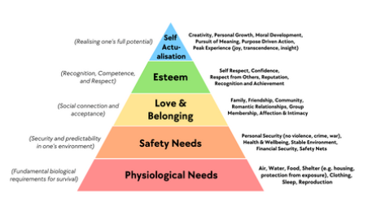 | 6
Deploy funding appropriated to ensure all DA pupils engage in the wider curriculum learning offer broadening experiences and engagement in learning. | Uptake in clubs, forest school, careers experiences, visits and musical tuition is increased by targeted provision for DA families. Cost does impact directly on this outcome. Percentage of DA engagement is lower where activities have a related cost.  Aspiration approaches are diverse and may focus on parents and families, teaching practice or out-of-school interventions or extra-curricular activities involving peers or mentors. When implementing aspiration interventions, schools might consider including:  - Guidance on the knowledge, skills, and characteristics required to achieve future goals.  - Activities to support pupils to develop self-esteem, motivation for learning or self-efficacy.  - Opportunities for pupils to encounter new experiences and settings.  - Additional academic support.  https://educationendowmentfoundation.org.uk/education-evidence/teaching-learning-toolkit/aspiration-interventions | 5

Total budgeted cost: £3,200 + £70,995 +£6,800 = £80,995

